DIS-INDO-Korwar-1968

A **korwar** (picture appears) is an older picture of the island of [Biak](https://translate.googleusercontent.com/translate_c?depth=1&hl=en&prev=search&rurl=translate.google.com&sl=nl&u=https://nl.wikipedia.org/wiki/Biak&usg=ALkJrhgclFGaK_zccFACTpPiPJOXRid6LQ) in [Geelvinkbaai](https://translate.googleusercontent.com/translate_c?depth=1&hl=en&prev=search&rurl=translate.google.com&sl=nl&u=https://nl.wikipedia.org/wiki/Geelvinkbaai&usg=ALkJrhiS0UjfcxKB7UDQF41gvsWbNOOCyg) or *Cenderawasih Bay in* the Indonesian province of [Papua.](https://translate.googleusercontent.com/translate_c?depth=1&hl=en&prev=search&rurl=translate.google.com&sl=nl&u=https://nl.wikipedia.org/wiki/Papoea_(provincie)&usg=ALkJrhiRRoYmP9n87U8cQfSdkBpg0HXr4g)

The images are taken with the aim of deceased ancestors who give bodiless on Earth wander a new body. The korwar is made of wood, in very rare cases of limestone. It has the shape of a huge head, standing on a small lower body, and thus has a primitive form of a human being. Originally, the skull of the deceased ancestor in the image was processed, and comprised the main part of the image of a wooden skull resting. The use of skulls for this purpose was banned at the beginning of the last century at the request of the mission by the Dutch government in Biak.

Korwars be installed in the living room, and can be used to predict the success of a prospective business or activity. If the image vibration or movement, is the leading activity, according to Biak dangerous and should be discouraged.

The ethnographic museums in the Netherlands - the [National Museum of Ethnology](https://translate.googleusercontent.com/translate_c?depth=1&hl=en&prev=search&rurl=translate.google.com&sl=nl&u=https://nl.wikipedia.org/wiki/Museum_Volkenkunde&usg=ALkJrhiRsE1nlAVdXo-l3y5Jw1BqMqfWjg) in Leiden, the [Tropical Museum](https://translate.googleusercontent.com/translate_c?depth=1&hl=en&prev=search&rurl=translate.google.com&sl=nl&u=https://nl.wikipedia.org/wiki/Tropenmuseum&usg=ALkJrhjaT95tOgW11wM_aChthpYcDG7IiQ) in Amsterdam and the [World Museum Rotterdam](https://translate.googleusercontent.com/translate_c?depth=1&hl=en&prev=search&rurl=translate.google.com&sl=nl&u=https://nl.wikipedia.org/wiki/Wereldmuseum_Rotterdam&usg=ALkJrhi6WtuUjmsxDsswBCtsCV_lLpXSsg) - have dozens Korwars in their collection. Leiden has a korwar from 1830 [[1],](https://translate.googleusercontent.com/translate_c?depth=1&hl=en&prev=search&rurl=translate.google.com&sl=nl&u=http://www.museumkennis.nl/lp.rmv/museumkennis/i001144.html&usg=ALkJrhgBHxhSB79aXsMo2ij1xwJ-nmEShw) the Tropenmuseum a gathered during the [Etna expedition](https://translate.googleusercontent.com/translate_c?depth=1&hl=en&prev=search&rurl=translate.google.com&sl=nl&u=https://nl.wikipedia.org/wiki/Etna-expeditie&usg=ALkJrhjOTePuSCgRkaBEEgG_XAG8WEEzmA) to northern New Guinea in 1858.

* Baaren, Th. P. van, *Korwars and korwar Style;* *Art and Ancestor Worship in North-West New Guinea.* The Hague, 1968.
* Duuren, D., "An old *korwar* from New Guinea in Amsterdam's Tropenmuseum", in:. *Tribal- the magazine or tribal art* IX-1, No. 34, Spring 2004, pp. 110-113.
* Smidt, DAM, "Korwars: striking images as mediators between the living and the dead", in M. Holsbeke (ed.), *The object as a mediator;* *about the transcendent meaning of art in traditional cultures.* Antwerp: Ethnographic Museum City of Antwerp, 1996, pp. 68-77.

## 01 décembre 2009

### Les Korwar de Cenderawasih

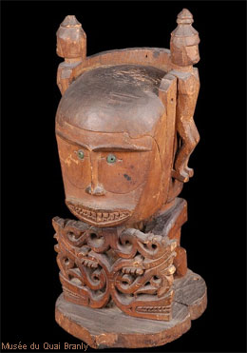

Dans le golfe de Cenderawasih, anciennement baie de Geelvink, l'on trouvait des petites statuettes en bois monoxyle, anthropomorphes, composées d’un personnage assis derrière un écran-bouclier ajouré qu’il tient de ses deux mains et sur lequel, parfois, appuie son menton.  
Telle est une image typique du korwar, emblème de la croyance en l’autorité des esprits ancestraux.  
Ce qui pose principale question dans l’interprétation de ces images concerne la signification de ce panneau-bouclier.

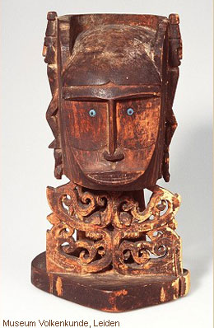

L'on a supposé que cela pouvait être un blason possédant une forme spécifique à chaque clan.   
Les motifs semblent dérivés de la représentation de serpent. Peut-être s'agit-il d'une marque à connotation positive : la mue du serpent est un symbole de renaissance.   
Si, dans chaque être, il existe une force vitale qu’il est important de capter et si l’on invoque l’âme d’un défunt à travers le korwar ; le panneau-bouclier deviendrait, lors du rite, une image métaphorique de cette force alors « accessible », puisque l’âme du défunt renaîtrait à cette occasion.  
Le personnage tient les corps des deux serpents : l'on peut y voir également le courage d’un homme qui terrasse des forces puissantes.

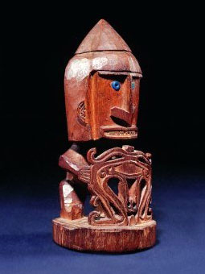

André Breton avait collectionné ce type d'objet ; et comme pour le [Uli de Nouvelle-Bretagne](http://detoursdesmondes.typepad.com/dtours_des_mondes/2007/09/tour-du-monde.html), il lui avait dédié [un poème](http://surrealisme.skynetblogs.be/post/6587211/andre-breton--korwar) (in Xénophiles).

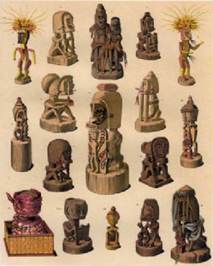

Photo 1 : Musée du Quai Branly.Photo 2 : Museum Volkenkunde, Leiden.Photo 3 : Colection André Breton, site http://www.andrebreton.fr/Photo 4 : Lithographie tirée de Clercq et Schmeltz, 1893, plXXXV ; Korwar collectés en 1887-1888.(http://www.esnips.com/doc/b12645fb-da1d-48c3-b376-679e6e3f5775)

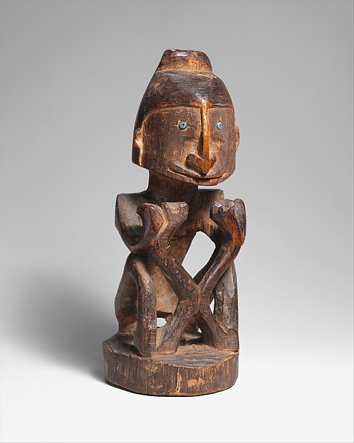

* [Add to MyMet](http://www.metmuseum.org/mymet)
* [Share](http://www.metmuseum.org/collection/the-collection-online/search/318765)
* [Permalink](http://www.metmuseum.org/collection/the-collection-online/search/318765)

## Ancestor Figure (Korwar)

Date: late 19th–early 20th century

Geography: Indonesia, Papua Province (Irian Jaya), Cenderawasih Bay region

Culture: Cenderawasih Bay

Medium: Wood, glass beads

Dimensions: H. 10 1/4 in. (26 cm)

Classification: Wood-Sculpture

Credit Line: Purchase, Fred and Rita Richman Gift and Rogers Fund, 2001

Accession Number: 2001.674

The peoples of the coasts and islands of Cenderawasih Bay in northwest New Guinea formerly created korwar, figures that portrayed recently deceased ancestors. Formerly in the collection of the Surrealist poet and theoretician André Breton (1896–1966), this remarkable korwar exemplifies the distinctive approach to the human form that prompted many Surrealists to seek inspiration in Oceanic art. Korwar images served as supernatural intermediaries, allowing the living to communicate with the dead, who remained actively involved in family and community affairs. When a family member died, his or her relatives summoned a carver, typically a religious specialist, who created a korwar and enticed the spirit of the deceased to enter it.

Korwar imagery was highly conventionalized, depicting the ancestor in a seated or standing position with the robust head and arrow-shaped nose that are the hallmarks of Cenderawasih carving. Although the sex of the figures is often difficult to determine, all were either male or female, depending on the gender of the deceased. Kept by the family, korwar were consulted during crises and prior to important undertakings, such as trading voyages, warfare, or fishing. When a korwar's advice proved sound, it was shown great deference. However, if the advice a korwar provided proved wrong, the living at times vented their anger on the figure, hurling it against the walls or house posts or even destroying it.

